Project Requirements
- Read the business description in the report, fully understand the business requirements.

- Provide your answers in the context of the business description of your assignment.

3. The contents that should be included in the report are as follows:
(1)Definition of MIS
(2) Impacts of MIS
(3) DBMS
(4) Data Flow Diagram
(5) System success
(6) Decision-Making Process Model
(7) Information Threats
(8) F2b2C
(9) Model of Managing Knowledge

4. Format requirements
(1) Paper and page setting requirements
Paper size: standard A4 (210mm×297mm).
Margins: 25mm on top, bottom, left and right. header margin: 1.5cm, footer margin: 1.75cm.

(2) Font, size and spacing
Font: Times New Roman
Size: Other than the titles, 12 points, double spaced, first line indented.

- Figure: centered

(4)Table: centered

(5) Page numbering
From the beginning of the text to the end, number the pages with Arabic numbers, font Times New Roman, 10 points, centered.

5. Naming requirements
Final assignment-student number-name

Content

1.Project Overview 1
2.Definition of MIS 4
4.DBMS 11
5.Data Flow Diagram 14
5.1 Data Flow Diagram-Top 14
5.2 Data Flow Diagram-Level.1 14
5.3 Data Flow Diagram-Level.2 15
5.4 Data Dictionary 20
5.4.1 Data Flow 20
5.4.2 Processing Logic 20
5.4.3 Data Storage 21
5.4.4 Eternal Entity 21
6.System success 23
7.Decision-Making Process Model 27
8.Information Threats 30
9.F2b2C 34
10.Model of Managing Knowledge 36
11.Discussion 38

1.Project Overview
Hotel Arizona
Hotel Arizona is open to guests all year round with 222 air conditioned balconied rooms. 18 rooms are luxury suites that satisfy all needs. The hotel is also the largest conference and wellness centre of the region, equally attracting those wishing to relax and business travellers.
The purpose of its relaxing and refreshing programs is to allow guests to completely forget the negative effects of their everyday life and stress during their stay. The chef of the hotel and its team ensures culinary pleasures. In addition to seasonal specialties, traditional Hungarian cuisine and international fare, guests can choose from a wide variety of fitness and wellness foods.
However, the competition in the hotel industry is becoming more and more intense. In order to improve efficiency, increase sales of the hotel and establish a good image, the hotel decided to utilize management information systems, which should including the following functions.
- Room change management
The main purpose of room change management is to change rooms according to customers’ needs. Activities included are room inquiry, registration of room change, and confirmation of room change. The hotel will record guests’ reasons for room change, analyze whether they can change rooms immediately according to their booking channel and room types; and choose rooms for guests; After this, the hotel immediately change the status of related rooms.
- Room management
Its main functions are room status maintenance, expense record confirmation and handling guest inquiries. Staff can customize room types, including searching, entering and modifying basic information of room types (such as type name, area, bed, price, etc.). Staff can manage room information, including retrieval, entry and modification of the basic information of the room (such as room number, room type, room location, etc.).
- Reservation Management
The main purpose of reservation management is to improve the room opening rate of the hotel. Customers can check and reserve the available rooms in the hotel through this module. Customers can make withdrawal for the reserved room. Meanwhile, they can change personal information and check reservation records. The hotel will update the room information instantly according to the customers' reservation and withdrawals. For hotel administrators, they can search reservations, make changes, approve reservations, reject reservations, and delete reservations.
- Reception management
Reception management mainly concentrates on opening rooms for guests at the fastest speed. Its activities include guest registration, room availability confirmation, modification of guest information, deletion of guest information and query of guest information.
- Checkout Management
Checkout management include activities such as guest checkout and statement printing. Customers can pay in advance through the cell phone, member card, cash, bank cards. If customers need to change rooms, the hotel can check differences and charge or refund customers accordingly. When checking out, customers will get refund if their down payment is higher than their fees.

2.Definition of MIS
MIS stands for Management Information Systems. It refers to a system that helps organizations manage their information and automate various business functions. MIS typically involves the use of computer systems and software to collect, store, process, and present data in a structured and meaningful way to support decision-making and improve organizational efficiency.
According to the description of the article on the textbook, the components of the MIS is shown in the following diagram:
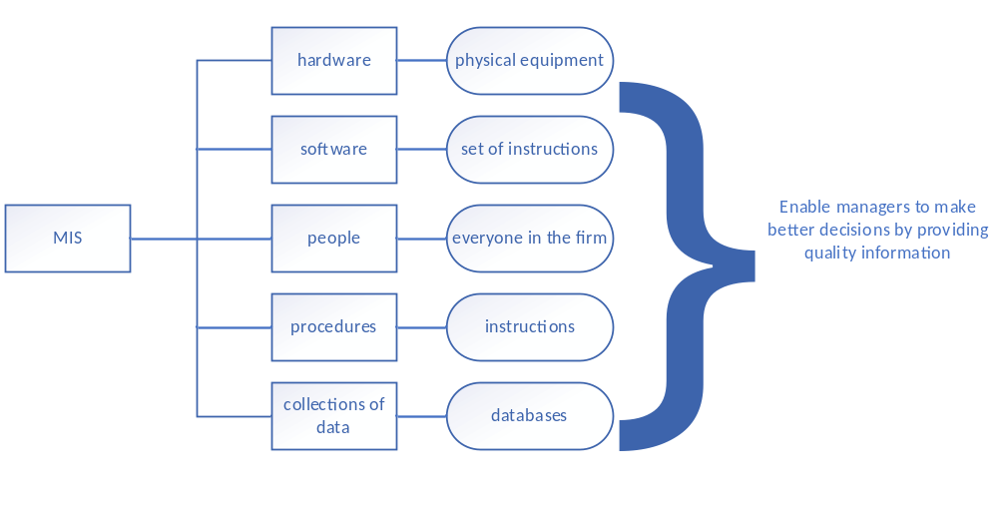Figure2.1 components of the MIS
In the hotel management information system, in addition to the programmers who develop the back-end and the managers who use the system to make decisions, this paper refers more to the front desk staff of the hotel who use the system to operate the business related to customer reservations.
In the context of Hotel Arizona, an MIS has been developed to support various functions within the hotel management. The MIS can facilitate each of the mentioned functions:
1. Room change management
The MIS enables the hotel to handle room change requests efficiently. It provides a platform for guests to inquire about room changes and register their requests. The MIS records the reasons for room change and analyzes the availability of suitable rooms based on booking channels and room types. It assists in selecting appropriate rooms for guests and promptly updates the status of related rooms.
2. Room management
The MIS helps in maintaining accurate and up-to-date information about the hotel's rooms. It allows staff to manage room types by searching, entering, and modifying details such as type name, area, bed, price, etc. Room information, including room numbers, types, and locations, can be retrieved, entered, and modified through the MIS.
3. Reservation management
The MIS streamlines the reservation process, improving the hotel's room occupancy rate. Customers can access the system to check available rooms and make reservations. They can also make withdrawals from their reserved rooms and update their personal information. The MIS updates the room availability instantly based on customer reservations and withdrawals. Hotel administrators can use the MIS to search, modify, approve, reject, and delete reservations.
4. Reception management
The MIS plays a crucial role in efficient guest check-in processes. It facilitates guest registration, confirms room availability, allows for modifications and deletions of guest information, and provides quick access to guest information through queries. By leveraging the MIS, the hotel staff can open rooms for guests promptly and ensure a smooth check-in experience.
5. Checkout management
The MIS supports the checkout process by handling guest checkouts and generating statements. Customers have the flexibility to choose various payment methods such as cell phones, member cards, cash, or bank cards. The MIS facilitates checking for any differences in fees due to room changes, enabling appropriate charges or refunds. If customers have made an initial payment higher than their fees, the MIS ensures a refund is issued during the checkout process.
Through the above analysis, it is easy to understand that the MIS implemented in Hotel Arizona automates and streamlines various aspects of room and guest management, reservation handling, and checkout processes. It enhances operational efficiency, data accuracy, and customer satisfaction by providing a centralized platform for managing information related to these functions.
Fundamentally, information technology like MIS improves individual productivity over traditional paper-based information recording methods. Front desk staff can quickly identify available rooms that meet customer requirements by customer preferences, order contents can be checked based on customer cell phone numbers, and teamwork and communication based on MIS will be more convenient. In addition to daily operations, the MIS also serves as a data coordinator with more intuitive information processing, which helps management to analyze rationally and make decisions accordingly.
3.Impacts of MIS
There are some changes in the contemporary business environment, including internet growth and technology convergence, transformation of the business enterprise, globalization, rise of the information economy, time-based competition, and emergence of the digital firm.
Implementing an information system for the mentioned functions in Hotel Arizona can have several positive impacts on the organization. Here's an evaluation of the impacts of the information system on the hotel:
1. Improved Efficiency
The MIS can streamline various processes within the hotel, such as room change management, room management, reservation management, reception management, and checkout management. By automating these functions, the hotel staff can save time and effort, leading to improved efficiency in operations. For example, the system can automate the room change process, making it easier for staff to handle guest requests and update room statuses promptly.
2. Enhanced Customer Service
With the MIS, hotel staff can access guest information quickly and efficiently. This enables them to provide personalized services and respond to guest inquiries effectively. The system's reservation management functionality allows customers to check available rooms, make reservations, and modify personal information easily. The improved customer service can contribute to guest satisfaction and loyalty.
3. Increased Sales and Revenue
The reservation management module can help improve the room opening rate by providing real-time information on room availability. This enables customers to make reservations conveniently, and the hotel can update room information instantly based on reservations and withdrawals. By optimizing room occupancy, the hotel can increase sales and revenue.
4. Data Analysis and Decision-Making
The MIS can collect and store data related to room changes, reservations, guest information, and more. This data can be analyzed to gain insights into customer preferences, booking patterns, and other trends. Hotel administrators can use this information to make informed decisions, such as adjusting room rates, offering promotional packages, or improving specific services based on guest feedback.
5. Improved Financial Management
The checkout management functionality of the MIS can facilitate accurate and efficient billing processes. It can calculate fees, handle refunds, and generate statements for guests. The system's integration with payment methods like cell phones, member cards, and bank cards provides flexibility and convenience for guests during the checkout process.
6. Streamlined Operations
The MIS can centralize and automate various tasks, reducing manual errors and paperwork. It allows for easy retrieval and modification of room and guest information, which simplifies administrative tasks and reduces the chances of data duplication or inconsistencies. This streamlining of operations can contribute to better overall management and organization within the hotel.
7. Competitive Advantage
In a highly competitive hotel industry, adopting an MIS can provide Hotel Arizona with a competitive edge. By leveraging technology to enhance efficiency, customer service, and decision-making, the hotel can differentiate itself from competitors and establish a positive brand image. The ability to offer a seamless and convenient experience for guests can contribute to the hotel's reputation and attract more customers.
In conclusion, the implementation of an MIS in Hotel Arizona can lead to improved efficiency, enhanced customer service, increased sales and revenue, better decision-making, streamlined operations, improved financial management, and a competitive advantage in the market.

4.DBMS
Files are necessary when organizing data. When the files are properly arranged and maintained, users can easily access and retrieve the information they need. A database management system is like a more advanced file, and it can overcome many of the problems of traditional file environments, such as data redundancy, program-data dependence, inflexibility, poor data security, and inability to share data among applications.
DBMS stands for Database Management System. It is a software system that allows organizations to efficiently manage and organize their data. It provides a structured approach to storing, retrieving, and manipulating data in a database.
In the context of Hotel Arizona's Management Information System, a DBMS plays a crucial role in organizing and managing the data that is stored and used within the system:
1. Data Organization
A DBMS allows Hotel Arizona to organize its data in a structured manner. Instead of using separate files or spreadsheets for each aspect of the hotel's operations (such as room management, reservation management, guest information, etc.), the DBMS provides a centralized database that integrates all relevant data into a cohesive system. This centralization enables efficient storage, retrieval, and management of data.
2. Data Integration
The DBMS ensures that data from different modules and functions within the MIS can be easily integrated and accessed. For example, guest information from the reservation management module can be linked to room management data, enabling seamless operations and providing a holistic view of guest-related information. This integration eliminates data duplication, inconsistencies, and redundancy, improving the accuracy and reliability of the information.
3. Data Security
A DBMS offers robust security features to protect sensitive data within the MIS. Hotel Arizona can implement access controls, authentication mechanisms, and data encryption to safeguard guest information, financial records, and other confidential data. This ensures compliance with data protection regulations and minimizes the risk of data breaches or unauthorized access.
4. Data Consistency and Integrity
With a DBMS, Hotel Arizona can enforce data consistency and integrity rules. This means that the data stored in the database will adhere to predefined rules and constraints, ensuring that the information is accurate and reliable. For example, the DBMS can enforce constraints on room types, pricing, and availability, preventing inconsistencies or conflicting data entries.
5. Efficient Data Retrieval and Analysis
The DBMS provides efficient data retrieval capabilities, allowing hotel staff to access and retrieve information quickly. For example, front desk personnel can retrieve guest information, reservation details, and room availability in real-time, facilitating smooth check-ins and enhancing customer service. Additionally, the DBMS enables data analysis by providing tools and techniques to query and analyze data, allowing Hotel Arizona to gain insights, make informed decisions, and improve operational efficiency.
6. Scalability and Flexibility
As Hotel Arizona grows and evolves, the DBMS offers scalability and flexibility in managing its data. The system can handle increasing volumes of data without significant performance degradation. It can also accommodate changes in the organization's data requirements and adapt to new business needs, such as adding new modules or functionalities to the MIS.
By leveraging a DBMS within its MIS, Hotel Arizona can ensure efficient and effective file management, leading to improved information processing, reduced costs, better performance, and increased flexibility. It ensures data integrity, consistency, and availability, enabling efficient operations, accurate information, and streamlined processes throughout the hotel. The DBMS enables the hotel to leverage its data as a valuable asset, supporting informed decision-making, enhancing guest experiences, and maintaining a competitive edge in the hotel industry.
At a deeper level, the data is processed and analyzed in the database management system, and the hotel management information system can analyze the user profile of customers to understand their selection preferences, and the travel information around the holidays can also be used to make appropriate adjustments to the rooms within the acceptable range of tourists during the high and low seasons, thus improving the hotel's revenue.

5.Data Flow Diagram
In this section, in order to facilitate the numbering to make the data flow diagrams clearer, instead of using the diagrams in the textbook or PowerPoint, the diagrams from the previous semester's Information Systems Analysis and Design course were used.

5.1 Data Flow Diagram-Top
For the hotel management information system, it is mainly operated by the staff to complete the management. Customers provide reservation information, registration request, room change request and checkout request through a series of room reserving operations, obtain room information through the hotel information management, and complete the update of information in the room information data pool and reservation information data pool.
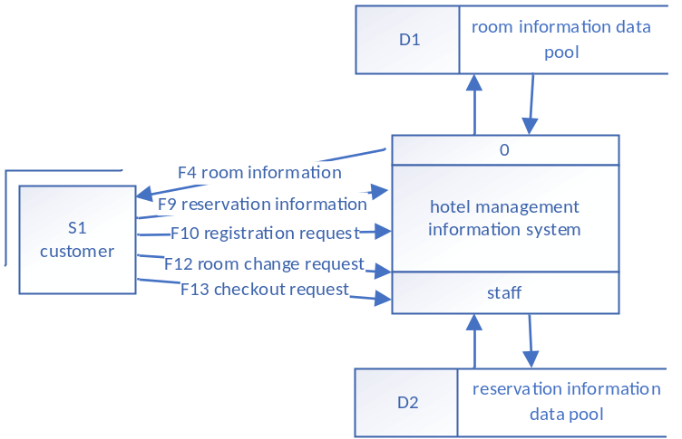
Figure5.1 Data Flow Diagram-Top

5.2 Data Flow Diagram-Level.1
The staff carries out the following operations through the management system:
If a customer reserves a room in Hotel Arizona, staff needs to retrieve the data in the reservation information data pool. If it is the first time to reserve a room in this hotel, customer needs to provide detailed personal information, if not, staff can directly manage the reception. If the room has been reserved, the reservation management is carried out by retrieving the data in the reservation information data pool. If the customer has the need to change the room, according to the requirements, refer to the data in the room information data pool and the reservation information data pool to find the appropriate room for room change management. When the customer needs to check out, he or she submits an application, and the checkout management checks the data in the reservation information data pool to see if there is any change in the order amount caused by withdrawal or modification. When the room information needs to be adjusted, it is necessary to modify the relevant information in the room information data pool and the reservation information data pool for room management.
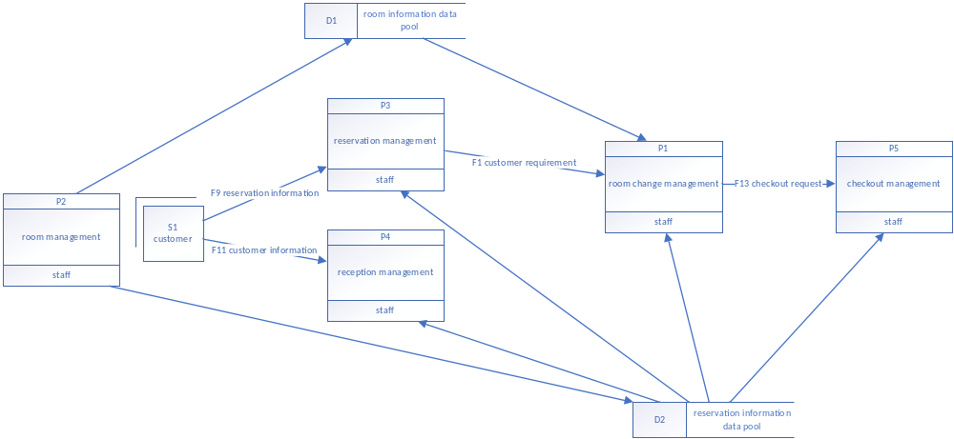 Figure5.2 Data Flow Diagram-L1

5.3 Data Flow Diagram-Level.2
1. Room Change Management
Room inquiry: Customer initiates a room inquiry by providing their requirements and preferences.
Room availability analysis: The system checks the availability of suitable rooms based on the customer's inquiry, booking channel, and room types.
Room change registration: If a suitable room is found, the customer's room change request is registered, including the reason for the change.
Room change confirmation: After analyzing the availability and selecting a suitable room, the system confirms the room change and updates the related room's status.
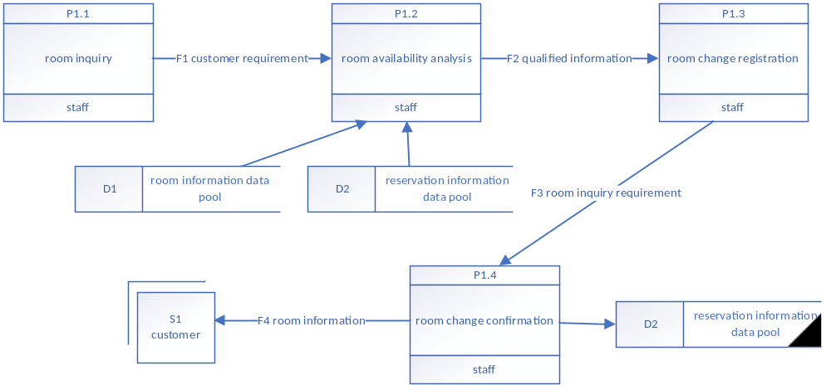 Figure5.3 Room change management DFD
2. Room Management
Room type customization: Staff search, enter, and modify basic information of room types such as name, area, bed, and price.
Room information management: Staff retrieve, enter, and modify room information including room number, room type, and room location.
Expense record confirmation: Staff confirm and update expense records related to room management activities.
Guest inquiries handling: Staff handle guest inquiries related to room information, availability, and amenities.
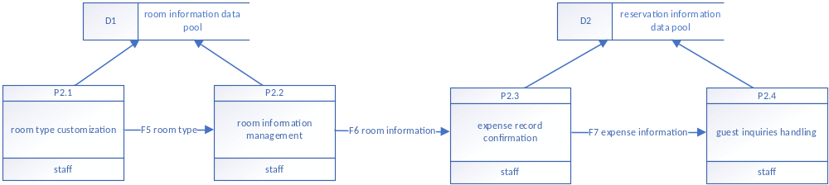 Figure5.4 Room Management DFD
3. Reservation Management
Room availability check: Customers check the availability of rooms in the hotel through the reservation module.
Reservation creation: Customers make reservations by selecting an available room and providing their personal information.
Reservation withdrawal: Customers withdraw their reservations if needed, which updates the room availability instantly.
Reservation modification: Customers can modify their reservation details, such as personal information or reserved room.
Reservation approval, rejection, and deletion: Hotel administrators search, approve, reject, or delete reservations based on their management decisions.
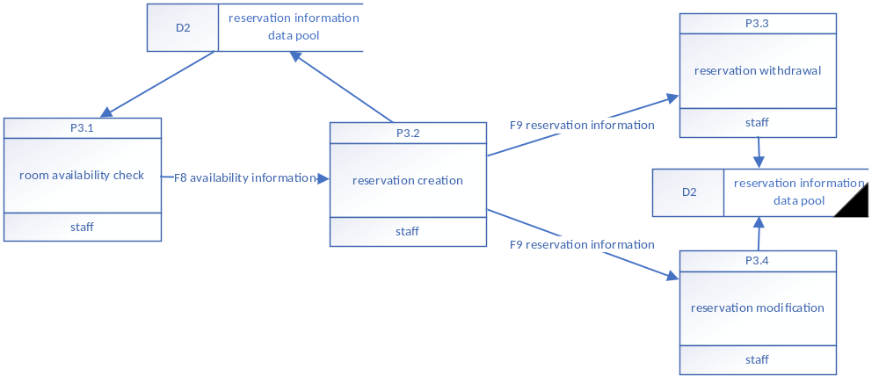 Figure5.5 Reservation Management DFD
4. Reception Management
Guest registration: Reception staff register guests by collecting their personal information and assigning rooms.
Room availability confirmation: Staff confirm the availability of assigned rooms for guests during check-in.
Guest information modification and deletion: Staff can modify or delete guest information as needed.
Guest information query: Staff can query guest information for various purposes, such as assisting guests or managing reservations.
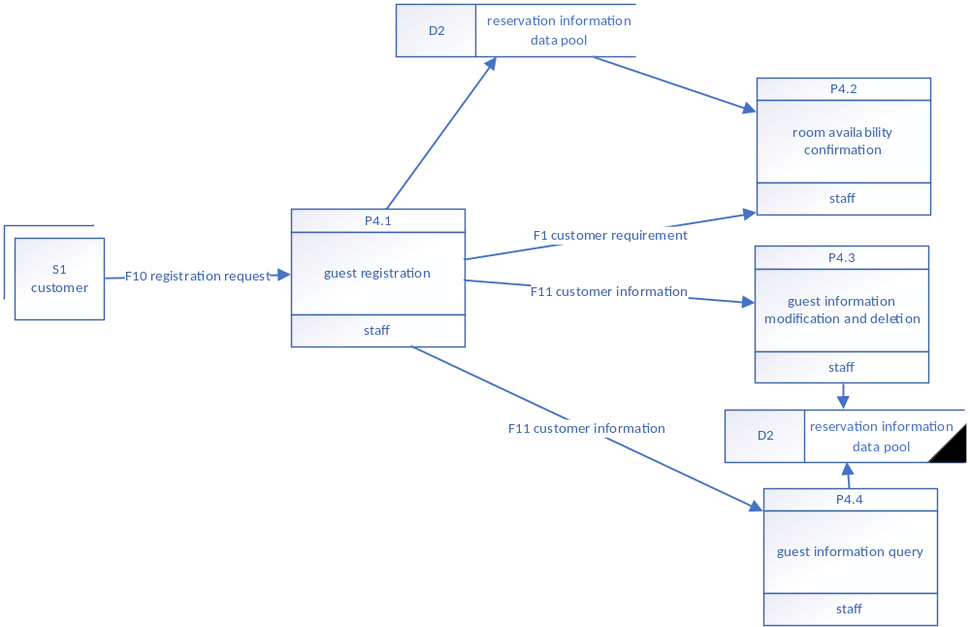 Figure5.6 Reception Management DFD
5. Checkout Management
Room change verification: If customers have changed rooms during their stay, the system checks for any differences in fees and adjusts the charges or refunds accordingly.
Guest checkout: Customers initiate the checkout process, indicating their intention to leave the hotel.
Payment processing: Customers can make payments in advance through different methods such as cell phone, member card, cash, or bank cards.
Refund processing: If a customer's down payment exceeds their total fees, they receive a refund during the checkout process.
Statement printing: The system generates a statement summarizing the customer's charges and payments for their stay.
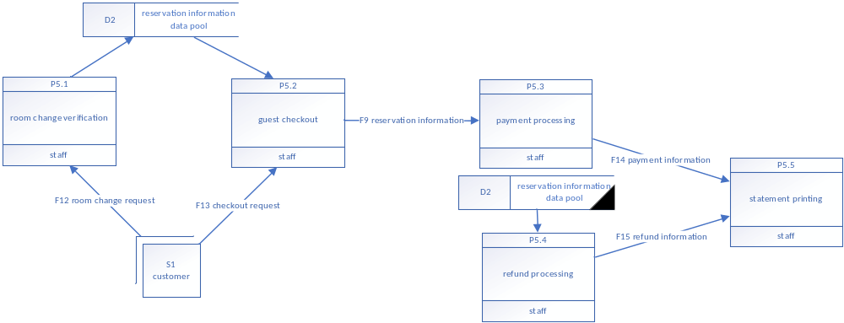 Figure5.7 Checkout Management DFD

5.4 Data Dictionary
The components of Data Flow Diagrams in the Data Dictionary are as follows:

5.4.1 Data Flow
Table 5.1 Data Flows
No | Description | Source | Destination
F1 | F1 customer requirement | P1.1 | P1.2
F2 | F2 qualified information | P1.2 | P1.3
F3 | F3 room inquiry requirement | P1.3 | P1.4
F4 | F4 room information | P1.4 | S1
F5 | F5 room type | P2.1 | P2.2
F6 | F6 room information | P2.2 | P2.3
F7 | F7 expense information | P2.3 | P2.4
F8 | F8 availability information | P3.1 | P3.2
F9 | F9 reservation information | P3.2, P5.2 | P3.3, P3.4, P5.3
F10 | F10 registration request | S1 | P4.1
F11 | F11 customer information | P4.1 | P4.3, P4.4
F12 | F12 room change request | S1 | P5.1
F13 | F13 checkout request | S1 | P5.2
F14 | F14 payment information | P5.3 | P5.5
F15 | F15 refund information | P5.4 | P5.5

5.4.2 Processing Logic
Table 5.2 Processing Logics
No | Name | Input | Output | Handler
P1.1 | room inquiry |  | F1 | staff
P1.2 | room availability analysis | F1, D1, D2 | F2 | staff
P1.3 | room change registration | F2 | F3 | staff
P1.4 | room change confirmation | F3 | F4, D2 | staff
P2.1 | room type customization |  | D1, F5 | staff
P2.2 | room information management | F5 | D1, F6 | staff
P2.3 | expense record confirmation | F6 | D2, F7 | staff
P2.4 | guest inquiries handling | F7 | D2 | staff
P3.1 | room availability check | D2 | F8 | staff
P3.2 | reservation creation | F8 | D2, F9 | staff
P3.3 | reservation withdrawal | F9 | D2 | staff
P3.4 | reservation modification | F9 | D2 | staff
P4.1 | guest registration | F10 | D2, F1, F11 | staff
P4.2 | room availability confirmation | D2, F1 |  | staff
P4.3 | guest information modification and deletion | F11 | D2 | staff
P4.4 | guest information query | F11 | D2 | staff
P5.1 | room change verification | F12 | D2 | staff
P5.2 | guest checkout | D2, F13 | F9 | staff
P5.3 | payment processing | F9 | F14 | staff
P5.4 | refund processing | D2 | F15 | staff
P5.5 | statement printing | F14 | F15 | staff

5.4.3 Data Storage
Table 5.3 Data Storages
No | Name | Composition
D1 | room information data pool | room type, room number, room location, area, bed, price, availability status
D2 | reservation information data pool | reservation detail, customer personal information, reserved room number, reservation status, modification record, withdrawal record

5.4.4 Eternal Entity
Table 5.4 Eternal Entity
No | Name | Input | Output
S1 | customer | F4 | F10, F12, F13
Based on the data flow diagrams, decision trees and decision tables can be used to help clarify the program logic during the real project implementation.

6.System success
There are several measures of system success, including high levels of system use, user satisfaction with the system, favorable attitudes of users about information systems and information systems staff, achieved objectives, and financial payoff to the organization.
To measure the system success, several key measures can be considered:
1. System Use
One measure of success is the level of system use within the organization. Monitor the system's adoption rate and usage patterns among staff and customers. Track the number of users who actively use the system for room change management, room management, reservation management, reception management, and checkout management. Compare the adoption rate with the overall user population to assess the system's acceptance and integration into daily operations.
Measure the time taken to perform tasks related to room change management, room management, reservation management, reception management, and checkout management before and after the system implementation. Evaluate if the system has improved efficiency by reducing manual efforts, automating processes, and streamlining operations. Calculate time savings to determine the system's impact on productivity and resource utilization.
Track the occurrence of errors or discrepancies in room change processes, room management, reservation management, reception management, and checkout management. Compare the error rates before and after implementing the system to assess its accuracy and effectiveness in reducing errors. Monitor the frequency of data inconsistencies, incorrect room assignments, payment discrepancies, and other relevant issues to evaluate the system's reliability.
Monitor the system's uptime and reliability to ensure smooth operations. Track system availability, response time, and the occurrence of any downtime or technical issues. Measure the system's performance against defined service level agreements to ensure it meets the organization's requirements and minimizes disruptions in daily operations.
2. User Satisfaction
Conduct surveys or interviews with both staff and customers to gather feedback on their satisfaction with the system. Ask questions about the system's usability, efficiency, and effectiveness in managing room change processes, room management, reservation management, reception management, and checkout management. Use rating scales or open-ended questions to collect specific feedback and identify areas for improvement.
3. Attitudes of Users
Another measure of system success is the attitudes and perceptions of users towards the MIS and the information systems staff supporting it. Positive attitudes, such as trust, confidence, and belief in the system's effectiveness, indicate that the system is meeting user expectations and adding value to their work processes.
4. Achieved Objectives
The extent to which the MIS achieves its specified goals and objectives is a significant measure of success. These objectives could include improving operational efficiency, increasing sales and revenue, enhancing guest experiences, streamlining processes, and reducing costs. Evaluating the actual outcomes against the intended goals can provide insights into the system's success in delivering the desired results. Additionally, analyze the impact of the system on revenue generation and room occupancy rates. Measure the increase in the room opening rate resulting from improved reservation management. Compare revenue figures before and after system implementation to determine if the system has positively influenced the hotel's financial performance. Track occupancy rates to assess if the system has contributed to maximizing room utilization.
5. Financial Payoff
The financial impact of the MIS on the organization is an important measure of success. This can be assessed by examining key financial metrics such as return on investment, cost savings, revenue growth, and profitability. For example, if the MIS has helped in improving efficiency, reducing errors, enhancing customer satisfaction, increasing occupancy rates, optimizing pricing strategies, or reducing operational expenses, it indicates a positive financial payoff and contributes to the system's success.
To measure these aspects of system success, Hotel Arizona can conduct surveys, interviews, and performance assessments among its staff members, customers, and management. Regular monitoring, data analysis, and feedback collection will provide valuable insights to continuously improve the system and ensure its success in supporting the hotel's operations. Analyzing system usage data, tracking performance metrics, and comparing actual outcomes with predefined goals can provide a comprehensive evaluation of the MIS's success in meeting the organization's objectives and generating value.

7.Decision-Making Process Model
There are four different stages in decision making: intelligence, design, choice, and implement. The decision-making process model can be applied when developing information systems for the mentioned business functions in Hotel Arizona. The overall flowchart is as follow.
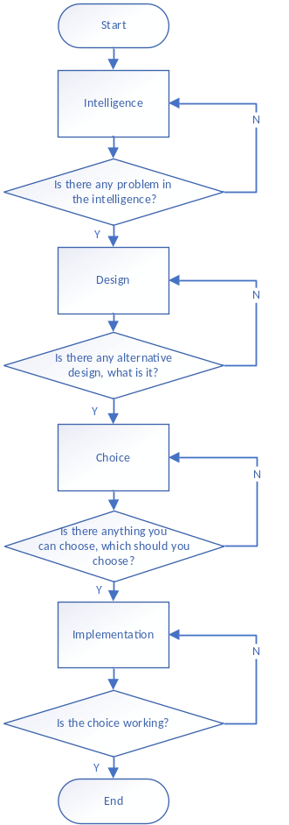
Figure 7.1 Decision-Making Process Flowchart
Applying the decision-making process model to the development of Hotel Arizona's information systems for the business function in the assignment, we can break down the stages as follows:
1. Intelligence
In the intelligence stage, the focus is on identifying problems and gathering information about the organization's performance and existing issues. In the case of developing Hotel Arizona's information systems, the intelligence stage would involve understanding the current challenges and inefficiencies in room change management, room management, reservation management, reception management, and checkout management. This stage would include conducting a thorough analysis of the hotel's operations, identifying areas where information systems can improve efficiency, customer satisfaction, and overall performance.
2. Design
During the design stage, possible solutions to the identified problems are developed. This stage requires intelligence to evaluate and determine the appropriateness of specific solutions. In this case, the design stage would involve creating information systems that address the identified challenges, such as developing a room change management system, a room management system, a reservation management system, a reception management system, and a checkout management system. Smaller Decision Support Systems can be utilized in this stage as they operate on simple models, can be developed quickly, and can operate with limited data.
3. Choice
The choice stage involves selecting the most suitable alternative from the options developed in the design stage. Information tools are utilized to calculate and assess the consequences, costs, and opportunities provided by each alternative. In the case of Hotel Arizona's information systems, this stage would involve evaluating different information system solutions, such as comparing different vendors or software options, considering the costs and benefits, and choosing the systems that best align with the hotel's needs. Larger Decision Support Systems may be employed to analyze various alternatives and complex models to account for all the consequences.
4. Implementation
The implementation stage focuses on putting the selected solution into action. It involves using reporting systems to track the progress of the implemented solution, identify difficulties, and suggest corrective actions. In the case of Hotel Arizona's information systems, this stage would involve implementing the developed information systems for room change management, room management, reservation management, reception management, and checkout management. Reporting systems, Management Information Systems, and project-planning software can be utilized to monitor the performance of the implemented solutions, identify resource constraints, and provide insights for further improvements.
By following this decision-making process model, Hotel Arizona can systematically develop and implement information systems that address the identified challenges, improve operations, enhance customer experiences, and achieve the desired outcomes.

8.Information Threats
When developing information systems for the mentioned business functions in Hotel Arizona, it is important to consider the potential information threats and implement measures to deal with them. Here are some of the biggest information threats and how they can be addressed:
1. Disasters
Disasters such as fires, floods, or hurricanes can have catastrophic effects on a company's data center and operations. To mitigate this risk, Hotel Arizona should implement a comprehensive disaster recovery plan. Data loss or system failures can result in the loss of critical information and disrupt the operations of room change management, room management, reservation management, reception management, and checkout management. Regular data backups and off-site storage should be implemented to prevent data loss. Redundancy and failover mechanisms can be employed to ensure system availability and minimize downtime.
Contracting with a disaster recovery services provider can also be considered, who offers commercial recovery facilities and support. Hotel Arizona can consider options like hot sites (fully configured computer centers ready for immediate use) or cold sites (functional computer room space without equipment), depending on their needs and budget. Regular backups of data should also be maintained and tested to ensure data recovery in the event of a disaster.
2. Employees and Consultants
Insider threats pose a significant risk to information security. Hotel Arizona should implement appropriate measures to minimize potential issues caused by employees or consultants. Insider threats pose a risk as employees or authorized individuals may misuse their access privileges or intentionally cause harm to the system or data. To mitigate this threat, appropriate access controls should be implemented, granting employees access only to the data and functionalities necessary for their roles. Regular monitoring and auditing of system logs can help detect any suspicious activities. Educating employees about the importance of data security, enforcing strong internal policies, and conducting background checks during hiring can also minimize the risk of insider threats. Conducting thorough background checks, using psychological tests during the hiring process, and enforcing separation of duties to prevent conflicts of interest are also necessary. Access to company computers should be promptly revoked when employees leave the organization. Additionally, Hotel Arizona should ensure that programmers and analysts are separate from users to maintain data integrity and security.
3. Business Partnerships
When sharing data with external business partners, Hotel Arizona needs to establish trust and ensure the security of information exchange. Prioritizing the selection of trustworthy partners and evaluating their security procedures is crucial. Hotel Arizona should consider implementing secure electronic data interchange protocols to securely exchange information with partners while limiting access to only the necessary data.
4. Outsiders
Unauthorized access from external sources, such as hackers or unauthorized individuals, poses a constant threat, which can lead to data breaches and compromise the confidentiality and integrity of guest information, room details, and financial transactions. Hotel Arizona should adopt standard security practices, such as regularly changing default passwords, implementing firewalls, and keeping operating systems and software up to date with the latest patches and updates. To address this threat, the system should implement robust authentication and access control measures. This includes secure user authentication methods such as strong passwords, two-factor authentication, and role-based access control. Encryption should be used to protect sensitive data during transmission and storage. Regular security audits and penetration testing can help identify vulnerabilities and ensure ongoing security. User education on safe online practices, including avoiding suspicious email attachments and not sharing passwords, is essential. Antivirus software should be installed and regularly updated to detect and remove known viruses.
Additionally, the information systems used for room change management, room management, reservation management, reception management, and checkout management may need to integrate with external systems or exchange data with third-party entities, such as online booking platforms or payment gateways. Ensuring secure and reliable data interchange through encryption, secure APIs, and adherence to industry standards and protocols is essential. Regularly reviewing and updating integration processes and conducting security assessments of third-party systems can help maintain data integrity and protect against vulnerabilities.
5. Viruses
Viruses, particularly those transmitted through email attachments, can cause significant damage to data and systems. Social engineering attacks, such as phishing or impersonation, can trick employees into revealing sensitive information or performing unauthorized actions. Hotel Arizona should implement strong antivirus software to detect and remove known viruses. However, since new viruses are created daily, antivirus software may not be sufficient. Regular backups of critical data are essential to ensure data recovery in case of infection. Implementing employee training programs to raise awareness about social engineering techniques and providing guidelines for identifying and responding to suspicious requests can help mitigate this threat. Regular communication with employees about security best practices and conducting simulated phishing exercises can enhance their ability to recognize and respond appropriately to such attacks.
By far, the biggest issues remain people inside the company and viruses. By addressing these information threats and implementing appropriate security measures, Hotel Arizona can minimize the risk of data loss, unauthorized access, and system disruptions, thereby ensuring the integrity and availability of their information systems.

9.F2b2C
F2b2C, which stands for "Factory to Business to Consumer," refers to a business model where a company sells products or services directly to end consumers through an intermediary business or platform. In the context of the Hotel Arizona and its management information systems, F2b2C would mean that the hotel utilizes an intermediary platform or business to reach and serve its customers.
For instance, Hotel Arizona could establish partnerships with online travel agencies or booking platforms that act as intermediaries between the hotel and the consumers. In this F2b2C model, the intermediary platform serves as the "business," connecting the hotel (the "Factory") with the end consumers (the "Consumer").
The developed system for the hotel's business functions integrates with the intermediary platform to enable seamless room bookings, reservation management, and other activities. The system provides real-time updates to the intermediary platform regarding room availability, rates, and other relevant information. Customers can access the intermediary platform to inquire about rooms, make reservations, and manage their bookings.
Implementing the F2b2C model brings several advantages for Hotel Arizona:
1. Increased Reach
By leveraging the intermediary platform, Hotel Arizona can tap into a larger customer base and reach potential guests who may not have been directly aware of the hotel.
2. Streamlined Bookings
The integrated system allows for efficient and automated handling of room bookings and reservations, reducing manual effort and potential errors.
3. Enhanced Customer Experience
Customers benefit from the convenience of using the intermediary platform, where they can easily compare room options, make reservations, and manage their bookings in one place.
4. Marketing and Promotion
The intermediary platform may also provide marketing and promotional opportunities for the hotel, helping to attract more customers and increase visibility.
However, it is crucial for Hotel Arizona to carefully select and manage its partnerships with intermediary platforms to ensure alignment with its business goals and maintain control over pricing, customer relationships, and data security. Regular monitoring and evaluation of the F2b2C model's performance will aid in identifying areas for improvement and optimizing the system's effectiveness in reaching and serving customers.

10.Model of Managing Knowledge
The model for managing knowledge can be applied to the business function in the management of Hotel Arizona to enhance its intellectual capital and overall knowledge management practices. The model consists of four stages, as shown in the figure below. The hotel can effectively manage its intellectual capital, which includes human capital, structural capital, and customer capital.
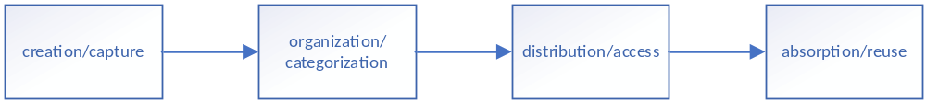 Figure 10.1 stages of managing knowledge model
1. Human Capital
Hotel Arizona can focus on the knowledge creation and absorption stages to enhance its human capital. This involves encouraging employees to share their knowledge, skills, and innovative ideas. The hotel can facilitate knowledge-sharing sessions, promote a culture of learning and collaboration, and provide platforms for employees to exchange ideas and experiences. By doing so, the hotel can increase the knowledge and expertise of its workforce, leading to improved service quality and innovation.
2. Structural Capital
The hotel can leverage the knowledge organization and distribution stages to strengthen its structural capital. This involves capturing and categorizing knowledge into tangible assets such as databases, organizational structures, and technological systems. Hotel Arizona can implement knowledge management systems that facilitate easy retrieval of information, promote efficient communication and collaboration among employees, and protect intellectual property through patents and trademarks. By effectively managing its structural capital, the hotel can enhance productivity, streamline operations, and foster innovation.
3. Customer Capital
Hotel Arizona can also benefit from managing its customer capital. This involves building strong relationships with customers and leveraging networks of associates. By providing exceptional service and creating positive experiences for customers, the hotel can establish a strong franchise and customer loyalty. Additionally, the hotel can gather customer feedback and preferences to improve its products and services, thus increasing customer capital. Hotel Arizona can employ customer relationship management systems and marketing strategies to cultivate and expand its customer capital.
To succeed in leveraging intellectual capital, Hotel Arizona needs to recognize the importance of both human and structural capital. This means adopting approaches that focus on fostering a knowledge-sharing culture among employees while also implementing appropriate technologies and systems for efficient knowledge management. By effectively managing its intellectual capital, the hotel can enhance its competitiveness, improve customer satisfaction, and drive innovation within the organization.

11.Discussion
In the last semester, I took a bilingual course on Information Systems Analysis and Design, which laid a certain foundation for me to study English for Information Management and Information Systems in this course. Compared with the previous semester's course, this course is more theoretical and relatively abstract, but the teacher helped me understand better by telling her own experience and examples from daily life, and also opened my vision and made me curious about the research and application of knowledge in my major’s field abroad. The memes on the PowerPoints also made the course vivid and interesting, which also helped me bridge the gap between theory and practice.. All of these helped me to have an overall grasp of the knowledge of this course to a certain extent. At the same time, this approach not only enhanced my understanding of the subject matter but also instilled in me a sense of confidence in applying the learned principles to real-life situations.
In my understanding, the hotel management information system is a system that is operated by the front desk staff most of the time, completing a series of business operations such as check-in, room change, and check-out. I don't know enough about some business processes. After searching some information on the Internet, I made the analysis in the article based on my understanding, which may not be accurate. But at least I think it is relatively reasonable.
For my final assignment about Hotel Arizona, I encountered some problems. The main reason is that I am not familiar enough with the details of this course, and I need to constantly review the content of the class through the textbook. What impressed me the most was the part of F2b2C. When I first analyzed the corresponding objects of factories, merchants, and customers, I regarded hotels as merchants, and customers customized hotel supplies from factories through hotels. Thinking twice, this is not reasonable. The market There are not many such related requirements on the Internet. Looking back at the textbook, in this model, a form of disinter-mediation occurs. Disintermediation is the use of the Internet as a delivery vehicle，whereby intermediate players in a distribution channel can be bypassed. The situation of this project is very similar to the example of travel agency booking airline tickets mentioned in the text, which helps me analyze the application of this project in the F2b2C model.
In addition, as mentioned in the text, when drawing the data flow diagrams, I did not use the diagrams presented in the textbook or the PowerPoints, but followed the diagram used in the Information System Analysis and Design course last semester, because, in my opinion, this makes labeling easier and the legend looks clearer. I hope the teacher can understand my “self-assertion”.
It's universally acknowledged that practice is based on theory, and only with a good theoretical foundation can we complete practice better. Hotel Arizona management information system was kind of abstract to me, so that I could not imagine more business processes, which was the biggest difficulty I encountered when applying the content of this subject to practice. However, it should not only be limited to the theory in books, but should be well converted into practical application in order to show its value.
Through the study of this course, I have learned a lot of English expressions in professional fields, which is helpful for me to study English papers in professional fields, learn advanced knowledge, and understand the development of the field. This acquired language proficiency will undoubtedly prove advantageous as I pursue future academic and professional opportunities, especially in an increasingly globalized world where English is the lingua franca of the business and technology sectors. In the future, I should deepen my understanding of professional knowledge with the help of what I have learned in the course.
Furthermore, the course fostered an environment conducive to critical thinking and problem-solving. In the class, the teacher pointed out the mistakes in the textbook several times, t his also gave me some inspiration.
In terms of the final assignment on Hotel Arizona, it presented a practical opportunity for me to apply the concepts learned throughout the course. Although I encountered difficulties due to my limited familiarity with the subject matter, I approached it with determination and utilized available resources, such as the textbook and online research, to overcome the challenges. This assignment not only tested my understanding but also reinforced the importance of thorough research, attention to detail, and effective communication in translating theoretical knowledge into practical outcomes.
Professional English for Information Management and Information Systems has been a transformative course for me. It has provided me with a strong theoretical foundation, enhanced my language skills, expanded my global perspective, and equipped me with critical thinking abilities essential for success in the field. As I move forward in my academic and professional journey, I am confident that the knowledge and skills gained from this course will continue to serve as a solid platform for my future growth and achievements in the field of information management and systems.

